1.1P: Preparing for OOP – Answer Sheet

1. Explain the following terminal instructions:
   1. cd: cd stands for change directory which is used when you’re working in a terminal
   2. ls: ls lists the files and directories in the current directory
   3. pwd: pwd stands for print working directory which is used to print the path or the working directory
2. Consider the following kinds of information, and suggest the most appropriate data type to store or represent each:

|  |  |
| --- | --- |
| Information | Suggested Data Type |
| A person’s name | String |
| A person’s age in years | Integer |
| A phone number | String |
| A temperature in Celsius | Float |
| The average age of a group of people | Integer |
| Whether a person has eaten lunch | Boolean |

1. Aside from the examples already provided in question 2, come up with an example of information that could be stored as:

|  |  |
| --- | --- |
| Data type | Suggested Information |
| String | Car Brands |
| Integer | Number of cars |
| Float | Length of the car |
| Boolean | Is Porsche designed in Italy? |

1. Fill out the last two columns of the following table, evaluating the value of each expression and identifying the data type the value is most likely to be:

|  |  |  |  |
| --- | --- | --- | --- |
| Expression | Given | Value | Data Type |
| 6 |  | 6 | Integer |
| True |  | True | Boolean |
| a | a = 2.5 | 2.5 | Float |
| 1 + 2 * 3 |  | 7 | Integer |
| a and False | a = True | True | Boolean |
| a or False | a = True | True | Boolean |
| a + b | a = 1  b = 2 | 3 | Integer |
| 2 * a | a = 3 | 6 | Integer |
| a * 2 + b | a = 2.5 b = 2 | 7 | Integer |
| a + 2 * b | a = 2.5  b = 2 | 6.5 | Float |
| (a + b) * c | a = 1  b = 1  c = 5 | 10 | Integer |
| “Fred” + “ Smith” |  | Fred Smith | String |
| a + “ Smith” | a = “Wilma” | Wilma Smith | String |

1. Using an example, explain the difference between **declaring** and **initialising** a variable.

The difference between the two is declaration is when you declare a variable with a name, and a variable can be declared only once. Initialising is when we put a value in a variable.

Example:

*Int x (Declaration)*

*Int x = 7 (Initialisation)*

1. Explain the term **parameter**. Write some code that demonstrates a simple of use of a parameter. You should show a procedure or function that uses a parameter, and how you would call that procedure or function.

A parameter is a special kind of variable used in a function to refer to one of the pieces of data provided as input to the function.  
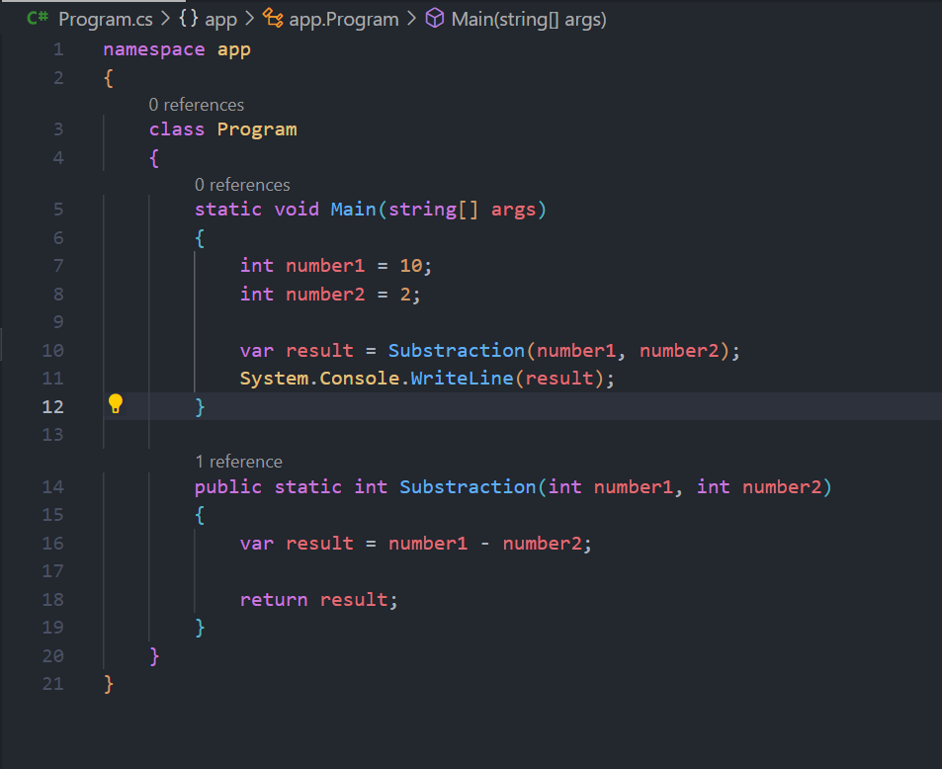

1. Using an example, describe the term **scope** as it is used in procedural programming (not in business or project management). Make sure you explain the different kinds of scope.

Scope is the area of the program where an item (be it variable, constant, function, etc.) that has an identifier name is recognized.

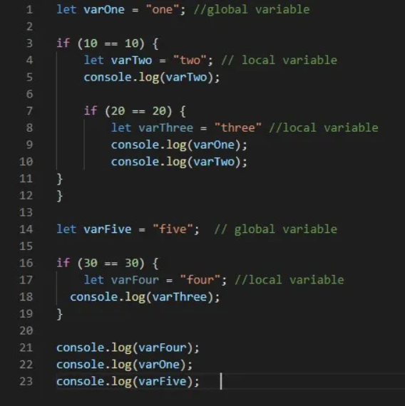

The console.log(varThree) at line 18 will throw a ReferenceError: varThree is not defined because it cannot be accessed except where it was defined.

The console.log(varFour) at line 21 will also throw ReferenceError: varFour is not defined because varFour is a local variable and it is not accessible outside its scope.

While the console.log(varOne) at line 22 and console.log(varFive) at line 23 print one and five respectively because both varOne and varFive are global variables.

1. In a procedural style, in any language you like, write a function called Average, which accepts an array of integers and returns the average of those integers. Do not use any libraries for calculating the average. You must demonstrate appropriate use of parameters, returning and assigning values, and use of a loop. Note — just write the function at this point, we’ll *use* it in the next task. You shouldn’t have a complete program or even code that outputs anything yet at the end of this question.

1. In the same language, write the code you would need to call that function and print out the result.

1. To the code from 9, add code to print the message “Double digits” if the average is above or equal to 10. Otherwise, print the message “Single digits”. Provide a screenshot of your program running.

